**Practical 6**

**Develop an IoT application that will raise an alarm whenever with going to rain outside based on the weather prediction data.**

**Steps to Perform:**

**Step 1:** 1) Take Alarm

2) Take Component - MCU Board

3) Take Humiture Sensor

4) Take Humiture Monitor

5) Take Humidifier

**Step 2:** 1) Now we will connect the Alarm to MCU Board with

IoT custom cable connect Alarm (D0) to connect with MCU Board (D0)

2) Then we will connect the MCU Board Humiture sensor with

IoT custom cable connect MCU Board (D1) to connect with Humiture sensor (A0)

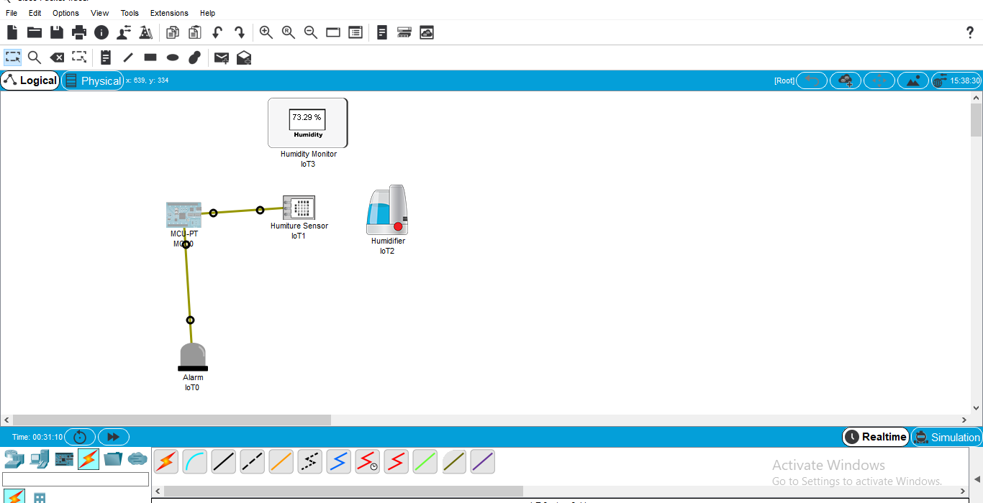

**Step 3 :** 1) Now click on MCU Board go to Programming then Select New, Select Template-

Empty-Python then click on Create

2) Click on main.py file then write code

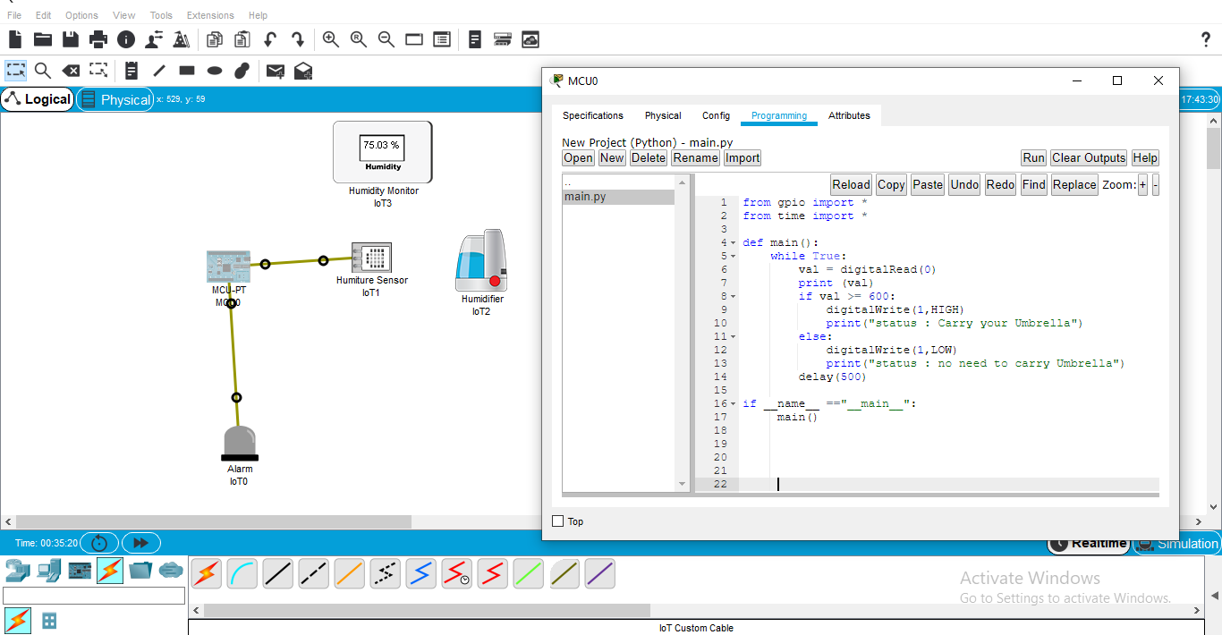

**Code:**

from gpio import *

from time import *

def main():

while True:

val = digitalRead(0)

print (val)

if val >= 600:

digitalWrite(1,HIGH)

print("status : Carry your Umbrella")

else:

digitalWrite(1,LOW)

print("status : no need to carry Umbrella")

delay(500)

if __name__ =="__main__":

main()

**Step 4 :** 1) Click on Run

